Much progress has been made on the Time-Reversal aspect of the Self-Healing project. The experiments are fully detailed in the papers that are being submitted for both the AIAA and SPIE conferences. This will briefly reiterate over those details and cover a few more that were not included in the abstract papers.

The tests used our National Instruments FPGA DAQ card contained inside the PXI Chassis. This is linked to our desktop development computer and run by a program written in the LabVIEW programming software. Linked to the DAQ card is a shielded input/output box that provides the capability of multiple read/write analog channels. We configured the box so that we used a total of three channels. Two of the channels were used to both send and receive signals, while the third channel was only used to read signals. Ceramic piezo electric stacks (PZT) were used to propagate and receive the signals. The pathway between the I/O box and the PZTs were coaxial cables. In order to enable the DAQ card to read the voltage input from the PZTs, a 1 M ohm resistor was placed in parallel across of the wires of each coaxial cable (i.e. one resistor per PZT, with a total of three PZTs). The wave transmission medium was a solid steel rod measuring 1 foot in length. We attached the two read/write PZTs to each end of the rod using accelerometer putty. The third, read-only PZT was attached behind one of the read/write PZTs also with the accelerometer putty (Figure 1). For the testing performed, switchable magnetic bases were used to clamp the rod and PZT apparatus together. The apparatus was placed on top of a small piece of Plexiglas that laid flat against the optics table. One magnet base was placed against one end of the rod with PZTs and was locked into place. The other magnet was pushed firmly against the other end of the apparatus and was then locked into place. The piece of Plexiglass was then removed, leaving the rod with PZTs suspended above the optics table (Figure 2).

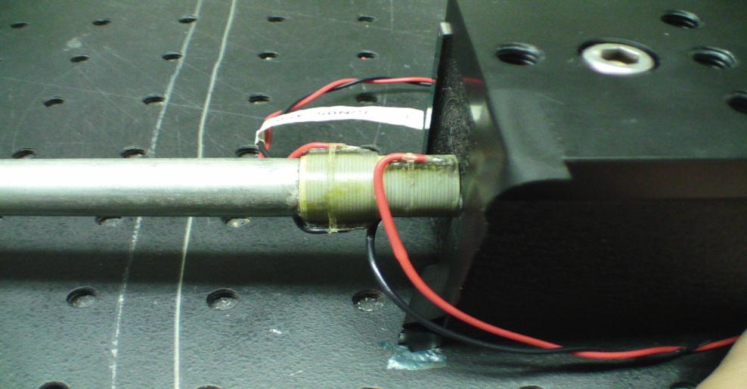

**Figure 1. Two PZTs together. Left one is read/write, right one is read-only.**

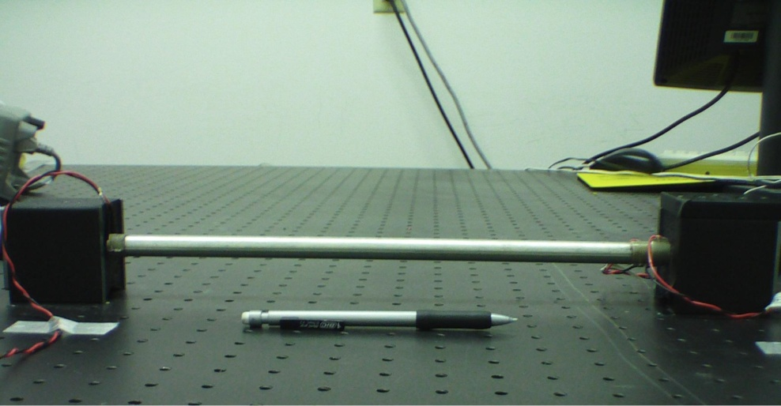

**Figure 2. Full setup with switchable magnetic bases.**

The setup is one thing that has been changed. Tests were performed that showed that the amount of force used to clamp the testing apparatus affected the response given by the PZTs. It was determined that a method in which a consistent amount of tension between test runs had to be developed. Preliminary design work has resulted in the use of bolts and optics table test assembly equipment. A completely fixed end is used on one side of the rod with PZTs (Figure 3). The other end is similar except that it uses an adjustable bolt with two nuts locked into place in order to tension the testing apparatus to the same amount of force each time (Figure 4). In the middle between the end clamps, bolts were placed into the optics table in a manner that allows for the same alignment of the rod with PZTs for each experiment run. Metal, optics table base plates are pushed into place against the bolts in the table (Figure 5).The rod with PZTs is then placed on the plates and pushed against the risen bolts so that it is made perpendicular to both ends (Figure 6).The adjustable end is then tensioned against the apparatus with a screwdriver until the locked nuts do not allow it to move any further. The metal plates are then removed from underneath of the rod, leaving it suspended above the optics table (Figure 7).

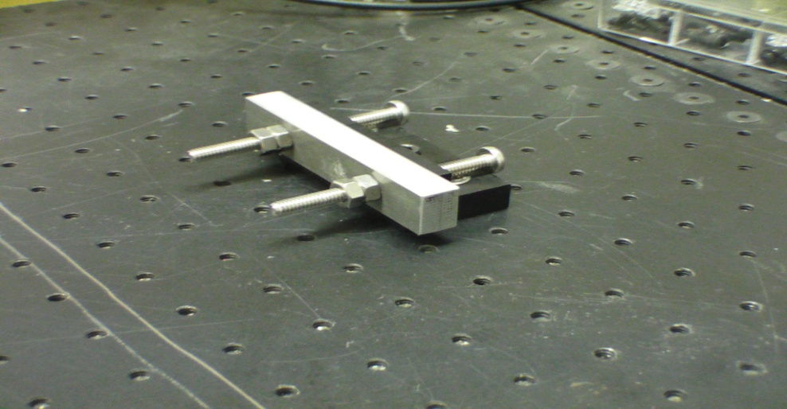

**Figure 3. Fixed end of tension mechanism.**

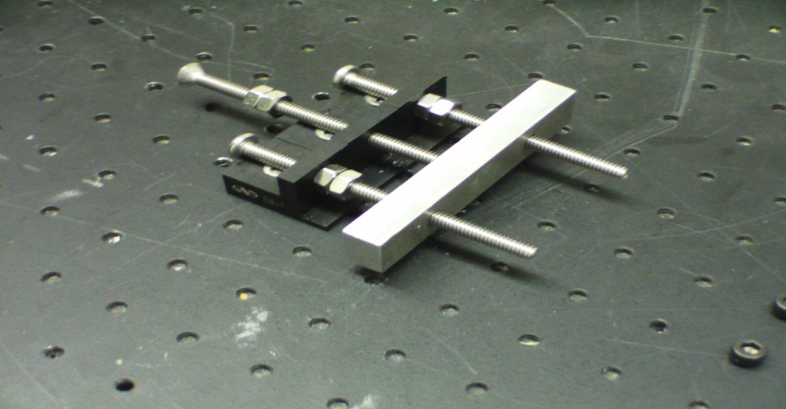

**Figure 4. Adjustable end of tension mechanism.**

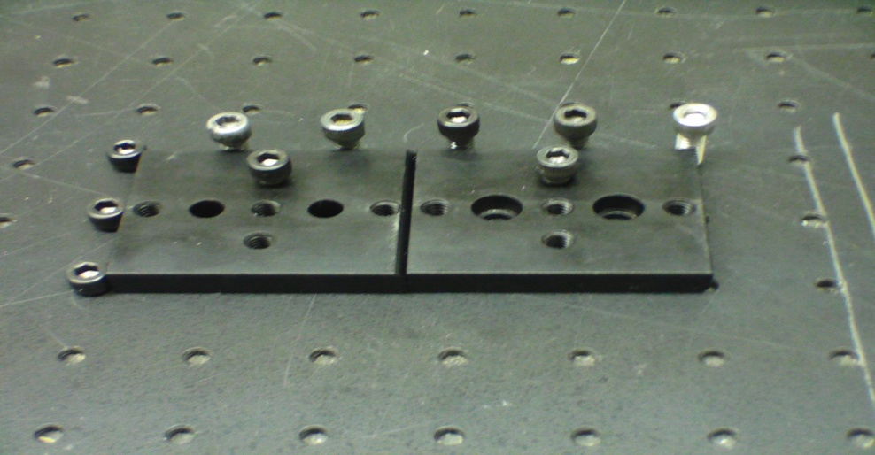

**Figure 5. Plates positioned against bolts in the table in order to get a consistent positioning of the rod and PZTs.**

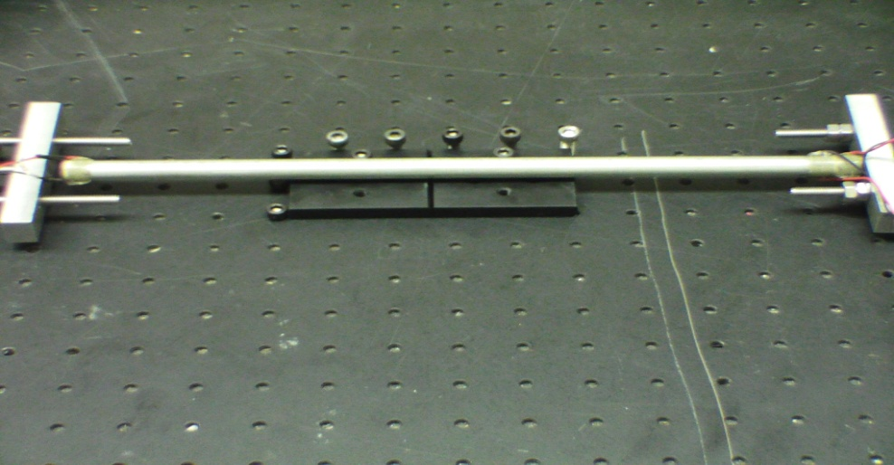

**Figure 6. Rod with PZTs placed on plates and made perpendicular to both ends of tension mechanism.**

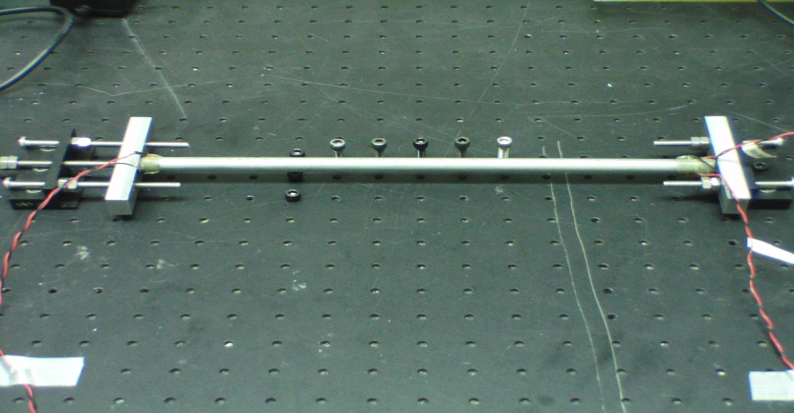

**Figure 7. New setup, with metal position plates removed and rod suspended above the optics table.**

A sinusoidal wave was setup in the testing program. This wave was then sent to the read/write PZT that did not have the read-only PZT attached to it. After writing out this signal, both read/write PZTs began recording. After a fixed number of samples had been read by each PZT, the data was sent back to the desktop computer to be manipulated for playback testing. Several different manipulations were performed in order to determine if time was in fact being reversed. After the data was changed to suit the needs of the current test, it was sent to its respective channels and played back. During this playback, the read-only PZT recorded all the signals it received and kept track of the maximum peak to peak amplitude that it achieved during the play back. After comparing results from the various tests, it was determined that the maximum peak to peak amplitude was obtained from reversing the data from both channels and placing one of them 180 degrees out of phase (i.e. multiplying by -1) (Figure 8). Analysis of graphs of the data yielded information that confirms the sinusoidal wave was being sent and received as expected, and also that it was focusing at the point that was predicted.

|  |  |
| --- | --- |
| Combination | Average Maximum Peak to Peak Amplitude Per Run (Volts) |
|  |  |
| Not Reversed | 0.843750 |
| Both Reversed | 0.918213 |
| Only Channel 0 Reversed | 0.790344 |
| Only Channel 1 Reversed | 0.846252 |
| Both Reversed, Channel 0 Phase Shifted 180 Degrees | 1.014770 |
| Both Reversed, Channel 1 Phase Shifted 180 Degrees | 1.009700 |
| Both Reversed, Both Phase Shifted 180 Degrees | 0.908142 |

**Figure 8. Chart showing results from testing.**

Further tests will involve the use of custom built voltage amplifiers made from printed circuit boards. These will be placed in a project box that is being constructed (Figure 9). These amplifiers will allow us to safely achieve a higher response from the PZTs and enable us to do future testing on epoxy filled brass tubes.

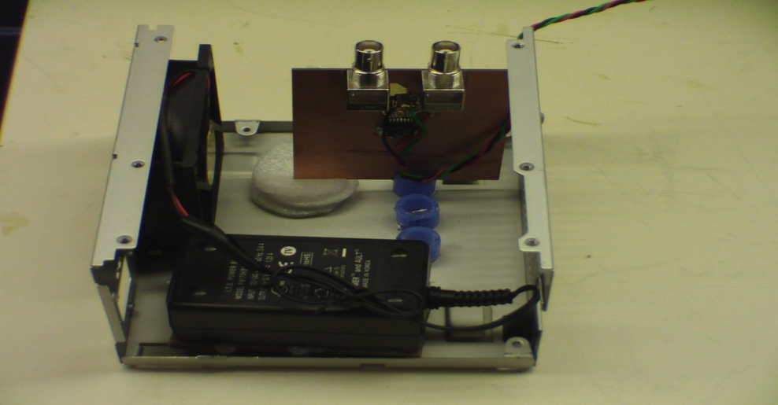

**Figure 9. Start of new project box to house custom built voltage amplifiers**